**Title : Transport Management System, DIU**

**Task-1(A) :**

I chose the Daffodil Transport Management System idea for my ISA course. There are some significant reasons behind this. Since the ISA course deals with information system analysis, firstly I had to choose an information system that follows all the steps of the system development life cycle. DIU Transport Management System is one such area. The reasons why I chose it are mentioned below :

**1 .Relevance and Significance:** It is a practical and real-world problem that needs an efficient solution. A Student Transport Management System is highly relevant for a university like DIU that offers transportation services to its students. It addresses a critical aspect of student life and improves the overall university experience.

**2. Complete SDLC Representation:** This project offers an opportunity to mention all phases of the System Development Life Cycle (SDLC). By starting with requirements gathering, moving through design, implementation, testing, deployment, and ongoing maintenance, it provides a comprehensive experience in systems analysis and development. This approach allows for a holistic understanding of the entire software development process.

**3. Addressing a Pain Point:** Like many educational institutions, DIU faces challenges related to managing student transportation efficiently. A dedicated Student Transport Management System can help in resolving issues such as scheduling, route optimization, tracking, student transport card utilization, and improve the overall quality of service.

**4. Improved Student Experience:** Implementing such a system will significantly benefit students. It will enhance their daily travel experience by providing real-time information about bus locations, reducing waiting times by providing schedules, continuous updates and increasing the safety and security of the transportation service. This improved service can positively impact student satisfaction.

**5. Efficiency and Cost Savings:** A well-designed Student Transport Management System can lead to more efficient route planning and resource allocation. As I’m adding a transport card system here, it will benefit the students about costing issues. This can also result in cost savings for the university by optimizing fuel consumption and reducing maintenance costs. These cost savings can be redirected into other university services or infrastructure improvements.

**Task-1(B) :**

Feasibility Analysis is a crucial phase in the development of any Information System including the "Student Transport Management System" for DIU. Feasibility analysis guides the organization in determining whether to proceed with a project and identifies the important risks associated with the project that must be managed.

Each organization has its own process and format for the feasibility analysis. Here, I include the most efficient feasibility techniques to assess my project :

**◦ Technical Feasibility :** Technical feasibility is the extent to which the system can be successfully designed, developed, and installed by the IT group. This section evaluates whether my project is technically feasible. It examines the technology and infrastructure required for the Student Transport Management System for DIU. Key points include -

**(i) Hardware and Software Requirements:** It’s an assessment of the hardware, software, and IT infrastructure needed for the system development and operation. For the transport management system,

* Server Device (must be a highly configured computer)
* Punch Card Machines (for transport cards)
* Server software

**(ii) Technology Stack:** It’s an exploration of the technologies, programming languages, and tools required for system development. For the transport management system,

In this project, the Web 2.0 technology will be used.

As for programming languages,

* Server site programming language - PHP (Hypertext Preprocessor)
* Client site programming language - JS (JavaScript) and
* Database management (query language) - MySQL.

**(iii) Data Integration:** It involves evaluating whether the integration of data from various sources and systems into the TMS is technically viable. Here, I have to Identify the different data sources that need to be integrated into the TMS. This could include,

* GPS devices on buses
* traffic and weather data
* student id and transport card data etc.

I have to Determine the data formats and communication protocols used by each data source and ensure that the TMS can handle and understand these formats and protocols and have to maintain the data accuracy and security.

**◦ Economic feasibility :** Economic feasibility analysis is also called a cost-benefit analysis, that identifies the costs and benefits associated with the system. For any new software project, it is necessary to know how much it will cost to develop and how much development time will take(as the cost depends on development time). The necessary steps will be -

**(i) Cost Estimation(Tk.):** It’s the estimation of the total cost of the project, including its development, hardware, software, and ongoing maintenance expenses.

| **Hardware** | | **Software** | | **Development** | | **Maintenance** | |
| --- | --- | --- | --- | --- | --- | --- | --- |
| Type | Cost | Type | Cost | Type | Cost | Type | Cost |
| (i) Server Computer | 2,00,000/= | (i) Server  Software | 12,000/= | (i) Domain  Hosting | 20,000/= | (i)Operational  Labour | 1,15,000/= |
| (ii) Punch Card Machines | 50,000/= | (ii) Server  License | 35,000/= | (ii) Full  Stack  Developer | 1,00,000/= | (ii) Others | 20,000/= |
| (iii) Others | 50,000/= |
| Total | 3,00,000/= |  | 47,000/= |  | 1,20,000/= |  | 1,35,000/= |

**Total Cost** = Hardware Cost + Software Cost + Development Cost + Operational Cost

= 3,00,000 + 47,000 + 1,20,000 + 1,35,000

= 4,94,000 ~

**(ii) Benefits and Return on Investment (ROI):** It’s the analysis of the expected benefits, both quantifiable and qualitative, and the calculation of the Return on Investment (ROI).

|  | Year-0 (Initial) | Year-1 | Year-2 | Year-3 |
| --- | --- | --- | --- | --- |
| Total Benefit | No benefit at break-even point | 2,12,500/= | 3,20,340/= | 5,26,980/= |
| Total Cost | 4,94,000/= | 16,000/= | 22,450/= | 18,050/= |
| Net. Benefit  (T.Benefit - T.Cost) | (4,94,000/=) | 1,96,500/= | 3,56,890/= | 5,08,930/= |
| Cumulative Net CashFlow | (4,94,000/=) | (2,97,500/=) | 59,390/= | 5,68,320/= |

Here, it seems that at Year-3, the Return on Investment will be gained and the project will be beneficial.

**(iii) Risk Assessment:** Identification of potential risks and uncertainties in the economic feasibility, with strategies for risk mitigation. The following risks may arise,

* Cost Overruns and Revenue Shortfalls
* Market Acceptance
* Legal and Regulatory Compliance
* Data Privacy and Security
* System Downtime And Resource Risks

**◦ Organizational Feasibility :** Organizational feasibility of the system is how well the system ultimately will be accepted by its users and incorporated into the ongoing operations of the organization. It evaluates whether the system can be smoothly integrated into the existing operational environment. For the DIU student transport management system, the key operational environment considerations include :

**(i) User Acceptance:** It’s a measurement of how well the system will be received and accepted by the students, staff, and administrators.

**(ii) Business Processes:** It’s an analysis of how the new system aligns with existing transportation and administrative processes at DIU.

**(ii) Training and Change Management:** It’s a plan for training staff and managing the transition to the new system. The faster the change is adapted to the environment, the sooner the risks will be reduced and will have the proper utilization of the TMS.

**Task-1(C) :**

A Business Requirement Document (BRD) focuses on the business perspective as it holds the details of the business solution for a project. Business requirements document also emphasizes the needs and expectations of the customer. In simpler terms, BRD indicates what the business wants to achieve. The BRD serves as a bridge between the business stakeholders and the project team, ensuring that both parties have a clear understanding of what needs to be accomplished.

A draft Business Requirement Diagram (BRD) for the project Student Transport Management System (DIU) is presented below,

**Table of Contents:**

1. Summary statement
2. Project objectives
3. Needs statement
4. Project scope
5. Financial statements
6. Functional Requirements
7. Personal needs
8. Schedule, timeline & deadlines
9. Assumptions
10. Cost & Benefit

**1. Summary statement for TMS:** The Student Transport Management System (TMS) at DIU is a comprehensive solution designed to enhance the quality, efficiency, and safety of student transportation services. By addressing critical challenges including scheduling, route optimization, real-time tracking, and the introduction of a student transport card system, the TMS seeks to revolutionize the student transportation experience. Its goal is to improve overall service quality, reduce waiting times, and offer students a more convenient, cost-effective, and secure means of commuting, ultimately elevating the standard of transportation services for the entire DIU community.

**2. Project objectives of TMS:**

The project objectives for the Student Transport Management System (TMS) at DIU are written below in the SMART(specific, measurable, attainable, realistic and time-bound) format,

* Specific (S):
  + Objective: To enhance the quality of student transportation services at DIU.
  + Details: Improving communication with the students, optimizing the schedule of the transport, implementing the card system and saving money and time of the students and emplyees.

Measurable (M):

* + Objective: To reduce student transportation cost and wait times for transportation services.
  + Details: Achieve a 30% reduction in transportation cost and 20% reduction in average waiting times within the first year of TMS implementation.
* Attainable (A):
  + Objective: To improve the travel experience and ensure safety and security of students.
  + Details: Implementing a card system that will be beneficial on both time and monetary issues and GPS tracking and real-time monitoring to ensure the safety of students during their journey.
* Realistic (R):
  + Objective: To optimize resource allocation for transportation services.
  + Details: Reduce fuel consumption by 15% within two years while maintaining or improving service quality.
* Time-Bound (T):
  + Objective: To provide data-driven insights for decision-making.
  + Details: Implement data analytics capabilities within the first six months of the project to support ongoing improvements.

**3. Needs statement of TMS:**

The Needs Statement for the Student Transport Management System (TMS) at DIU outlines why the project is essential for the university and how it will fulfill specific needs.

**Business Need:** Daffodil International University (DIU) recognizes the important role of efficient student transportation services to enhance the overall university experience. The existing manual transportation system has several limitations and inefficiencies that impact the quality of service and student satisfaction. So, there is an urgent business need to implement a comprehensive Transport Management System (TMS) that addresses these challenges and improves the transportation services at DIU.

**How the TMS Meets These Needs:** By constant scheduling, lessening prolonged waiting times, and providing real-time information, the system will improve the traveling experience. The introduction of a transport card system within the TMS is crucial to meet the financial and time-saving needs of the students. With this feature, students will be able to save money by purchasing transport cards at discounted rates, and they will save time with seamless, cashless boarding.

**4. Project Scopes of TMS:**

The scope of the Student Transport Management System (TMS) enclose a range of functionalities and features designed to enhance the efficiency, safety, and overall quality of student transportation services like -

* Route Planning and Optimization
* Scheduling and Timetable Management
* Transport Card System
* Security and User Authentication
* Mobile Application
* Real-Time Tracking and Communication

**5. Functional Requirements :**

The core requirements will be,

1. Route Planning and Optimization

2. Transport Card System

3. Scheduling and Timetable Management

4. Real-Time Tracking and Communication

5. Security and User Authentication

6. Integration with Existing Systems

8. Scalability

**6. Personal needs :**

The section outlines the human resource requirements for the successful development and implementation of the Transport Management System (TMS) at DIU. It specifies who needs to be hired and when the hiring needs to be done :

**1. Project Manager:**

* Role: Responsible for overall project management, including planning, execution, and delivery.
* Hiring Time: As soon as the project is initiated.

**2. System Analyst:**

* Role: To gather and document requirements, analyze data, and provide insights for system design.
* Hiring Time: During the project initiation and requirement analysis phase.

**3. Software Developers:**

* Role: Develop the TMS software, implement features, and ensure the system is functional and user-friendly.
* Hiring Time: As development starts, ideally during the design and implementation phases.

**7. Schedule, timeline & deadlines:**

In this phase, the duration of the project is covered. Here I’m creating a demo Schedule for all the stages,

| **Phase** | **Duration** |
| --- | --- |
| 1. Project Initiation | 2 weeks |
| 1. Requirements Gathering and Analysis | 4 weeks |
| 1. System Design | 5 weeks |
| 1. Development | 10 weeks |
| 1. Testing and Quality Assurance | 6 weeks |
| 1. Deployment | 3 weeks |
| 1. Data Analysis and Continuous Improvement | (Ongoing) |
| 1. Project Closeout | 1 weeks |

**8. Assumptions:**

The assumptions outline anticipated events that would occur during the course of the project. Assumptions for the Student Transport Management System (TMS) project at DIU are as follows: We assume that all necessary hardware and software infrastructure, such as servers, databases, and development tools, will be readily available and compatible with the project requirements. Additionally, it is assumed that the project team will have access to adequate financial resources for development, testing, and deployment phases. Furthermore, we assume that key stakeholders, including students, administrators, and drivers, will actively participate in the project, providing essential input and cooperation for system testing and feedback. Finally, the project assumes that there will be no major regulatory changes or external events that would significantly disrupt the project's progress during its execution.

**9. Cost & Benefit:**

From the feasibility analysis phase, we got the **Total Cost** **= 4,94,000** (including all costs)

And the **total benefit = 5,26,980**

It is fully shown in the economic feasibility part.

**Task-2(A) :**

Functional requirements outline in a detailed manner the functional requirements and corresponding features like charts and timelines. Here I’m showing all the functional requirements for the transport management system :

**1. Route Planning Module :** The possible routes are,

| **Route name** | **Route Details** |
| --- | --- |
| **Dhanmondi <> DSC** | **Dhanmondi - Sobhanbag <> Shyamoli Square <> Technical Mor > Majar Road Gabtoli <> Konabari Bus Stop <> Eastern Housing<> Rupnagar <> Birulia Bus Stand <> Daffodil Smart City** |
| **Uttara - Rajlokkhi <> DSC** | **Uttara - Rajlokkhi <> House building <> Grand Zamzam Tower <> Diabari Bridge <> Beribadh <> Birulia <> Khagan <> Daffodil Smart City** |
| **Tongi College gate<>DSC** | **Tongi College Gate Bus Stand <> Kamarpara <> Dhour <> Birulia <> Daffodil Smart City** |
| **ECB Chattor <> Mirpur <> DSC** | **ECB Chattor <> Kalshi Mor <> Mirpur 12 <> Mirpur 10 <> Mirpur 02 <> Mirpur 01 - Sony Cinema Hall <> Commerce College <> Gudaraghat <> Beribadh <> Eastern Housing <> Birulia <> Akran <> Daffodil Smart City** |
| **Konabari Pukur Par <> Zirabo <> Ashulia Bazar <> DSC** | **Konabari Pukur Par <> Norshingpur <> Ghosbag > Zirabo <> Ashulia Bazar <> Paragram <> Daffodil Smart City** |
| **Baipail <> Nabinagar <> C&B <> DSC** | **Baipail <> Palli Bidyut <> Nabinagar <> Bismail <> Prantik <> JU <> C&B <> Kolma <> Charabag <> Kumkumari <> Daffodil Smart City** |
| **Dhamrai Bus Stand <> Nabinagar <> C&B <> DSC** | **Dhamrai Bus Stand <> Kohinur Market <> Gonosastho <> Nabinagar <> Bismail <> Prantik <> JU <> C&B <> Kolma <> Charabag <> Kumkumari <> Daffodil Smart City** |
| **Savar <> C&B <> DSC** | **Savar Bus Stand <> Radio Colony <> C&B <> Kolma <> Charabag <> Kumkumari <> Daffodil Smart City** |
| **Narayanganj Chasara > Dhanmondi > DSC** | **Narayanganj Chasara > sign board >sonir akhra >saydabad bus stand > gulistan > Chankharpul> Nilkhet > New Market >kalabagan> Dhanmondi - Sobhanbag <> Shyamoli Square <> Technical Mor > Majra Road Gabtoli <> Konabari Bus Stop <> Eastern Housing Rup Nogor <> Birulia Bus Stand <> Daffodil Smart City** |
| **Green Model Town <> Mugdha Model Thana <> Malibagh <> Rampura <> DSC** | **Green Model Town > Bashabo > Malibagh Railgate South Bus Stop > Rampura Bazar Bus Stop > BTV Center > Aftabnagar > Badda Suvastu tower> Jamuna Future Park > Kuril Bisso Road > Khilkhet > Uttara - Rajlokkhi > House building > Diyabari Bridge > Beribadh > Birulia > Khagan > Akran Bazaar Bus Stand > Daffodil Smart City** |

**2. Scheduling and Timetable Management:**

* The system will allow administrators to create, manage, and modify bus schedules.
* Students will have access to the bus schedule and route details, helping them plan their commutes effectively.

**3. Transport Card System:**

* The system shall support the issuance of transport cards to students.
* Students shall be able to purchase and load transport cards, which will serve as a cashless payment method for bus fares.
* Transport cards shall provide discounted rates for students, reducing their transportation costs.
* Transport cards shall be reloadable, allowing students to add funds as needed.
* The system shall maintain a record of transport card transactions and balances.
* Students shall have the ability to report lost or stolen cards and request replacements.
* Administrators shall have access to card management features, enabling them to issue, block, or deactivate cards as necessary.
* The system shall integrate with payment gateways for card top-up and financial transactions.

**The functional requirement stage also shows charts and diagrams. I also added necessary diagrams to visualize the system.**

**Task-2(B) :**

**Here is the Zero Level Data flow diagram (DFD-0) :**

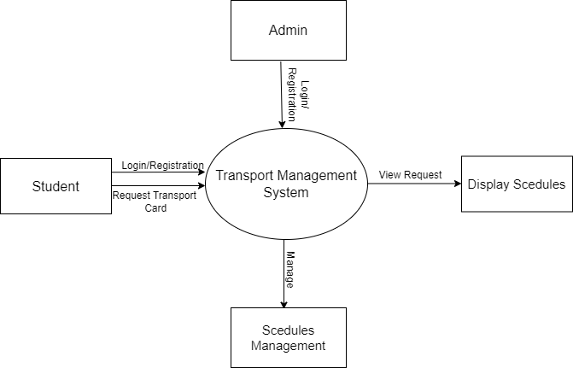

**Task-2(C) :**

**Here is the One Level Data flow diagram (DFD-1) :**

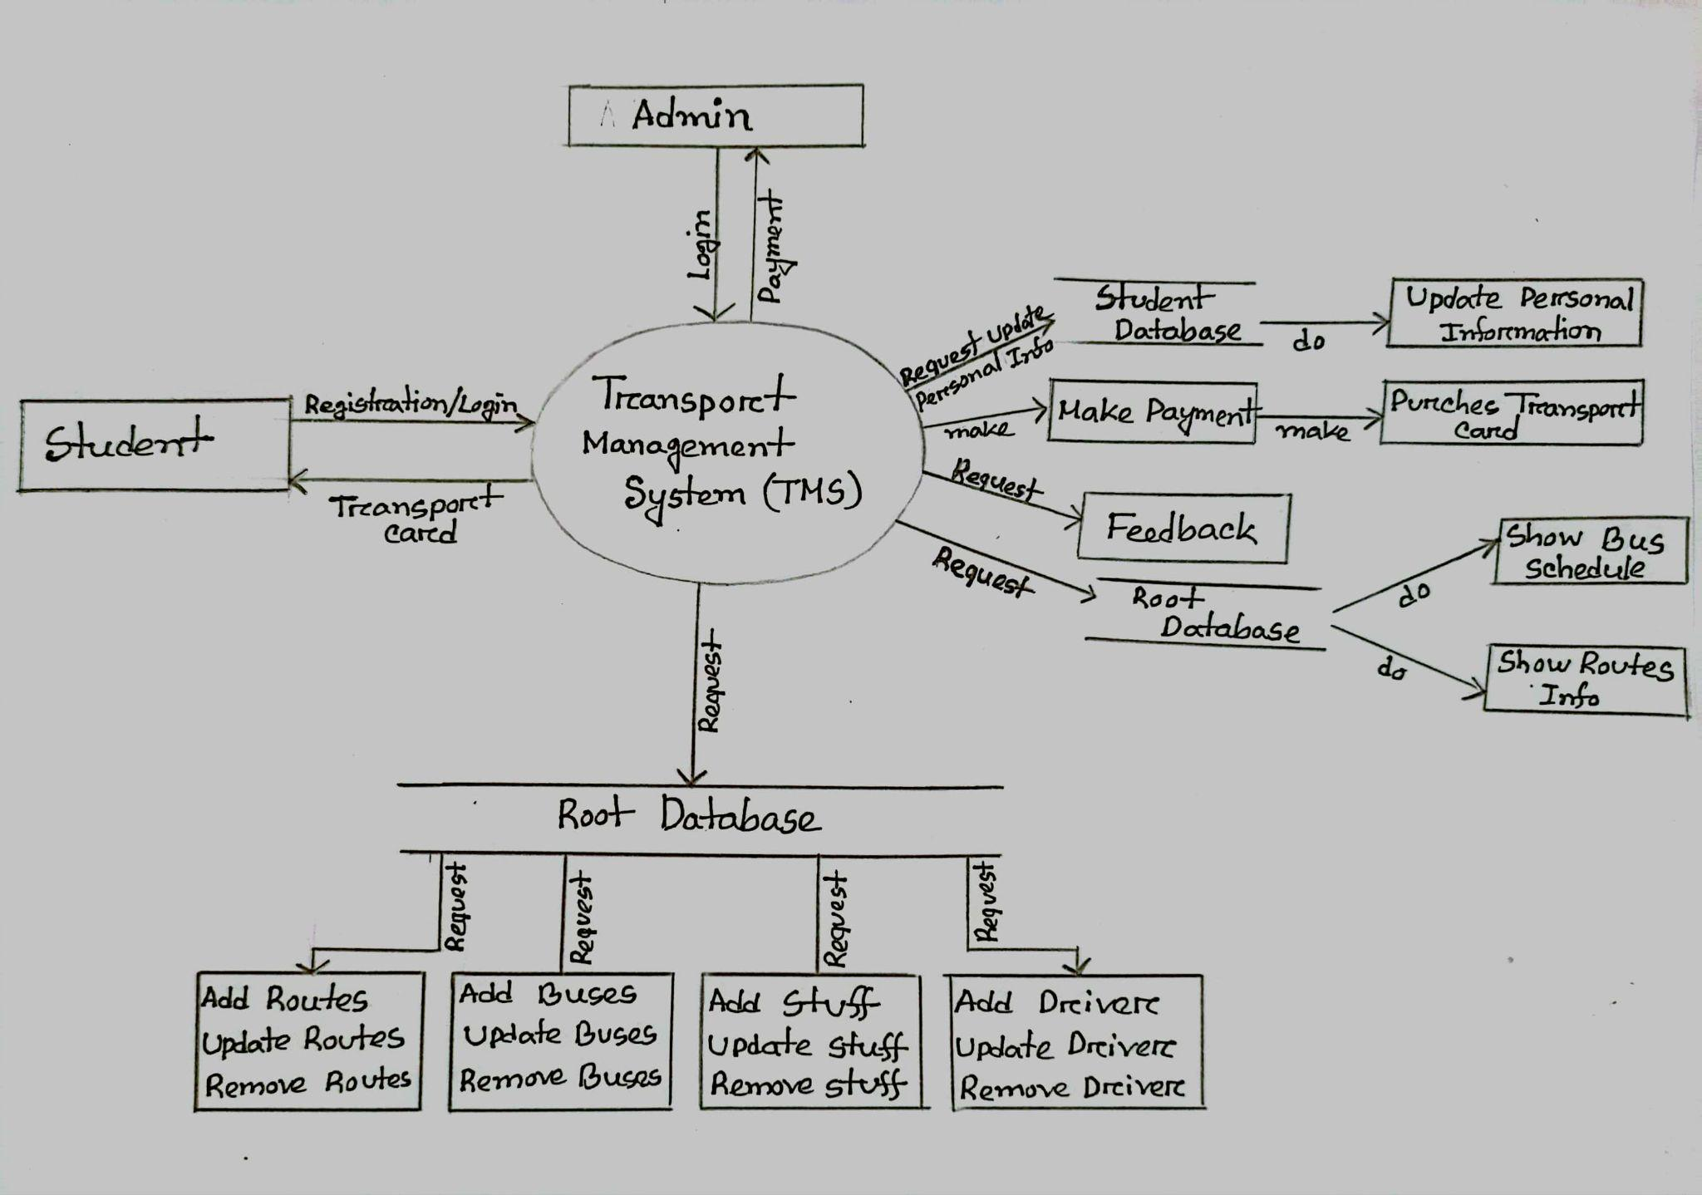

**Task-2(D) :**

**Here is the Use case Diagram for the Transport management System (DIU):**

**Transport management system (DIU)**

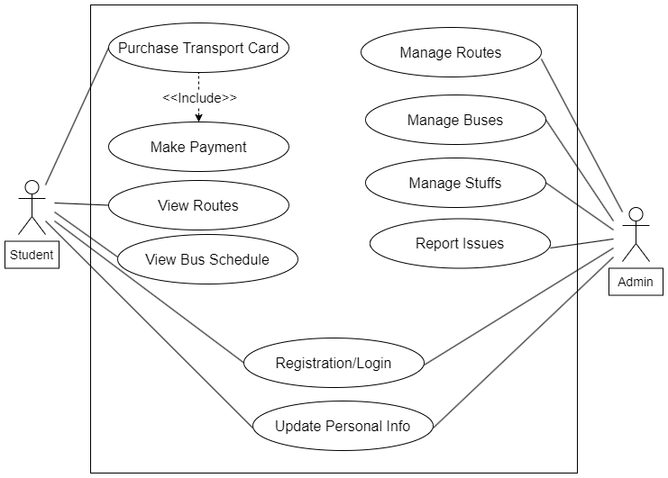

**Task-3(A) :**

The Student Transport Management System (TMS) at DIU (Daffodil International University) from social and environmental perspectives demonstrates the positive impact it can have on both the student community and the broader environment. Here are some of the beneficial aspects of the TMS project in these areas:

**Social Perspective:**

* **Improved Student Experience:**TMS significantly enhances the daily commute experience for students. Transport card system, static time scheduling, efficient route planning, and timely communication reduce waiting times, providing convenience and peace of mind.
* **Safety Enhancement:** The real-time tracking and communication features contribute to increased safety for students. Parents and guardians can also benefit from knowing their children's whereabouts during their commute.
* **Affordability:** The introduction of a transport card system with discounted rates saves students money, As it will allow prepayment system students not need to carry cash money and for each trip a fixed amount of transportation will be cut off .The extra money will be added again in renewal. So, this promotes social equity and affordability in education.
* **Reduced Stress:** By knowing when the bus will arrive and where it is, and as they do not need a manual ticket, students experience reduced stress and uncertainty in their daily commute, leading to a better quality of life.
* **Convenience:** The transport card system streamlines the payment process, eliminating the need for cash. This convenience factor is highly valued by students.
* **Data-Driven Decisions:** The data analytics module helps administrators make informed decisions about transportation services, allowing for continuous improvements that cater to students' evolving needs.

**Environmental Perspective:**

* **Fuel Efficiency:** Through optimized route planning and scheduling, the TMS reduces fuel consumption, contributing to lower carbon emissions and decreased environmental impact.
* **Reduced Traffic Congestion:** Efficient routes and schedules can help reduce traffic congestion around the university, which not only benefits the environment but also the broader community in the area.
* **Sustainability:** The use of transport cards encourages students to choose bus transportation over personal vehicles, reducing the overall environmental footprint of commuting.
* **Resource Optimization:** TMS supports better resource allocation, ensuring buses are efficiently deployed, which reduces environmental waste and inefficiency.
* **Eco-Friendly Image:** Implementing environmentally responsible transportation practices enhances DIU's image as a socially responsible institution.

**Conclusion :** The project was about the Transport Management System for the students of Daffodil International University. Hope it will successfully reduce the problem regarding transportation and perfectly collaborate with the existing system. Thank You.